Chapter 6: Inside the atom
Answers
Think about atoms
How did a plum pudding help scientists gain an understanding of atoms? | It provided a model of an atom that included negative and positive electric charge and led to further development of models of the atom.
How did Lord Rutherford find out that the atoms in solid gold are mostly empty space? | He fired alpha particles through a gold foil and found the great majority passed straight through without deflection. He concluded that the atom was largely empty space.
What causes radioactivity? | Some nuclei are unstable due to too many neutrons and protons or an n : p ratio that falls outside the limits of stability. These unstable nuclei then decay by emitting particles or rays. These nuclei are said to be radioactive.
Does ‘radioactive’ always mean ‘dangerous’? | No, as there are many radioactive substances in the natural environment. However, any form of artificial radioactivity should be regarded as dangerous, even if used for the treatment or diagnosis of disease.
How is uranium used in a nuclear reactor? | If slow neutrons are fired at the nuclei of uranium-238, then they cause fission with the release of vast amounts of energy. This energy can be used to boil water to produce steam that drives an electrical generator.
What’s the connection between radioactivity and fossils? | During their life, animals and plants take in small amounts of radioactive carbon-14. After their deaths, no more carbon-14 is absorbed and the remaining carbon -14 decays. It has a half-life of 5730 years. By measuring the amount of carbon -14 left in a fossil, the age of the fossil can be determined.
How is radioactivity used in the treatment of cancer? | Radioisotopes emit radiation such as beta and gamma. These radiations can be targeted on cancerous tissue and kill it.

Your quest
Do you have the inside information?
Answers will vary to some extent.
1. (a) Elements
(b) Elements
(c) Possible answers including the following.
- The atoms of the different elements that make up a compound are bonded together.
- A chemical reaction is required to separate the elements from a compound.
- The atoms or molecules of different elements and compounds that make up a mixture are not bonded together.
- A chemical reaction is not required to separate elements and compounds from a mixture.
(d)
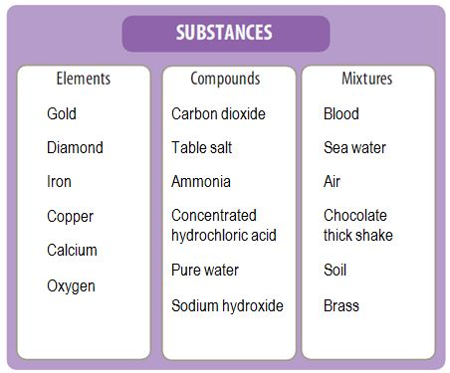
2. (a) A molecule is a group of atoms that are bonded together. Molecules can be made up of one or more types of atoms.
(b) Answers will vary (two required). Examples include nitrogen, hydrogen, oxygen and carbon.
(c) Answers will vary (two required). Examples include water, carbon dioxide, ammonia and methane.
(d) Answers will vary (one required). Examples include sodium chloride and calcium fluoride.
3. Protons, neutrons and electrons
4. (a) (iv)
(b) (ii)
(c) (i) and (iii)
Understanding and inquiring
6.1 Chemical building blocks
1. The atom has a small, dense central nucleus made up of protons (positively charged) and neutrons (carrying no electrical charge). The nucleus is surrounded by negatively charged electrons in electron clouds. Each electron is approximately 1/1870 the size of a proton. (Diagrams will vary.)
2. Protons, neutrons and electrons
3. Protons and neutrons are different in the charge they carry — protons are positive and neutrons are neutral. Protons and neutrons are the same size, and both are made up of tinier particles called quarks.
4. A proton is approximately 1870 times bigger than an electron; a proton has a positive charge, whereas an electron has a negative charge; protons are located in the nucleus, and electrons are found in electron clouds surrounding the nucleus.
5. The current model of the atom is a theory, because although it can be used to explain our observations, the model is updated as scientists learn more about the atom.
6. Dalton’s statement was correct in that an atom of a particular element is the smallest particle that can exist as that element. However, atoms themselves are made up of smaller particles, such as protons, electrons, neutrons, quarks and neutrinos. When they are broken up into these particles, they no longer have the properties of the element.
7. and 8. Individual student research: answers will vary.
6.2 Stability and change: Inside the nucleus
1. Isotopes of an element differ from each other in their number of neutrons. They have the same chemical properties but different physical properties, such as different masses.
2. (a) A = mass number = total number of protons and neutrons
(b) Z = atomic number = number of protons
3. The isotopes of some elements are radioactive because their nuclei are not stable. That is, the protons and neutrons in the nucleus are not held tightly together.
4. (a) Beta particle
(b) Alpha particle
(c) Gamma radiation
(d) Gamma radiation
5. Positive charge (2+)
6. The Earth's atmosphere protects us.
7. It is mostly beta radiation, with possibly a small amount of gamma radiation. The radiation contained no alpha particles because the sheet of paper had no effect on the readings; alpha particles would have been stopped by paper. If the radiation had been all gamma rays, the plastic would not have absorbed many of them and the Geiger counter reading would have remained relatively unchanged. However, the plastic would be enough to drop beta radiation by about two thirds. Also, beta radiation cannot travel through lead, hence the substantial drop in radiation when the lead was used. The implication that not all of the radiation was stopped by the lead could suggest that there was a small amount of gamma radiation being emitted from the source.
8. (a) 19 protons and 21 neutrons
(b) 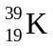
9. No. They do not have the same atomic numbers (proton number).
10. An alpha particle, as the mass number decreased by 4 and the atomic number decreased by 2
11. Two half lives = 2 × 4500 = 9000 days
12. and 13. Individual student research: answers will vary.
14. (a) 1 minute (The number of particles drops from 1600 to 800 in 1 minute.)
(b) 5 minutes is 5 half-lives, therefore only 50 particles are left (1600 → 800 → 400 → 200 t→ 100 → 50).
(c) Alpha radiation was produced. The alpha particles are helium nuclei.
6.3 Using radioactivity
1. Uranium undergoes a fission reaction in a nuclear reactor.
2. Radioactive elements can be used to trace the movement of substances through liquids, to date samples from archaeological sites, to preserve food and to produce electrical energy in nuclear reactors.
3. Radiotherapy is the use of radioisotopes or other radiation to kill cancer cells or prevent them from multiplying.
4. Internal radiotherapy involves placing radioisotopes inside the body, whereas external radiotherapy uses a machine to direct the radiation at the target cells from outside the body.
5. The radiation kills the micro-organisms in the food.
6. Iodine-131 is more stable than barium-137. We know this because barium-137 has a much shorter half-life than iodine-131.
7. Barium-137 has a half-life of only 2.6 minutes, so its radiation becomes insignificant too quickly to be a danger to the body.
8. to 12. Answers will vary.
13. (a) Three half-lives have passed. Therefore, the time that has passed is 17 000 years (to the nearest thousand years).
(b) (i) 11 000 years is a little less than two half-lives. Therefore, a little more than 25% (approx. 26%) of the original amount of carbon-14 remains.
(ii) 23 000 years is about four half-lives. Therefore, about 1/16th (approx. 6.2%) of the original amount of carbon-14 remains.
6.4 Concept maps and plus, minus, interesting charts
1. (a)
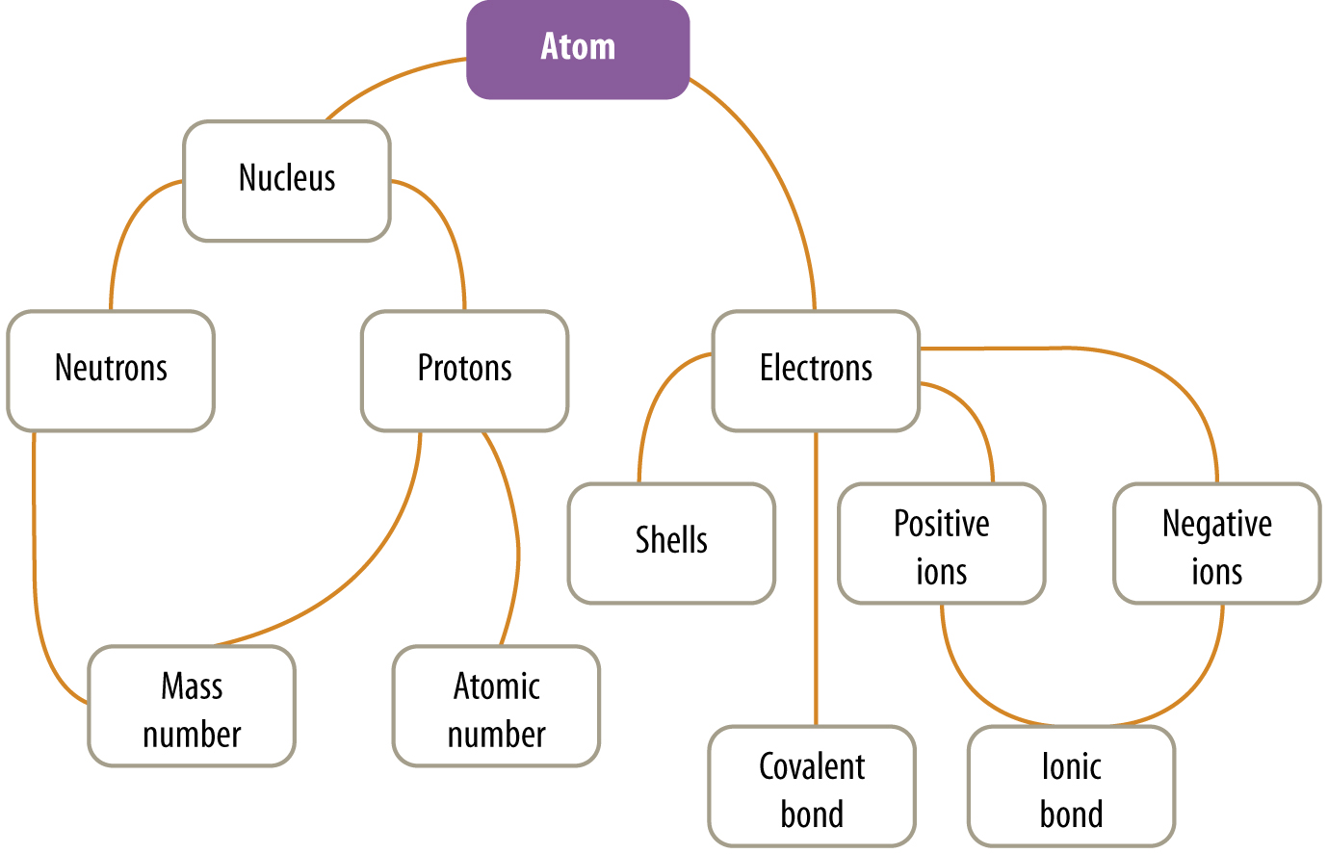
(b) A possible answer is shown.
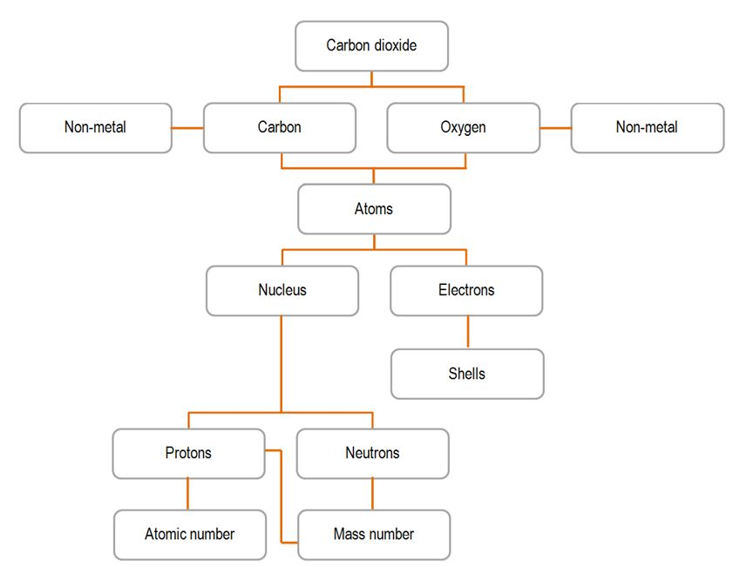
2. One possible answer:
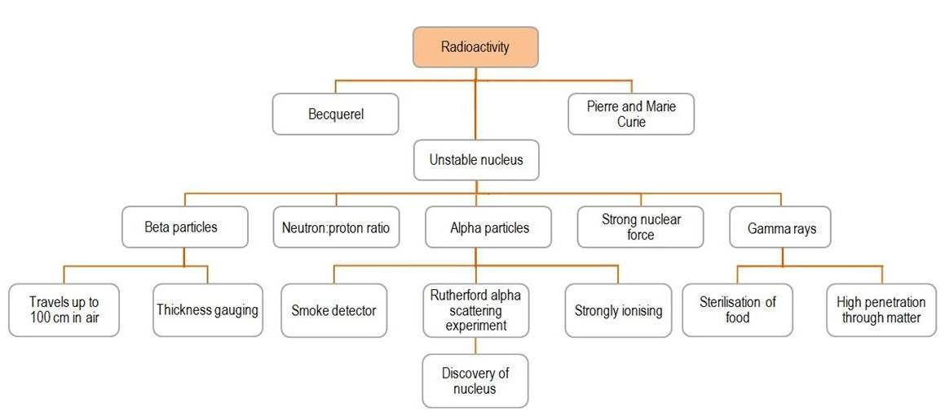
3. Individual or group activity
4. Individual or group research activity
Looking back
1. (a) Protons and neutrons
(b) Electrons
(c) Electrons
(d) Carbon
2. (a) Electron
(b) Proton
(c) Neutron
(d) Electron
3. (a) J. J. Thomson discovered the electron and proposed the plum pudding model of the atom.
(b) Lord Rutherford discovered the nucleus and proton, and proposed the solar system atomic model.
(c) Niels Bohr proposed that electrons were located in energy levels or shells around the nucleus.
4. (a) Hydrogen-1: one proton
Hydrogen-2: one proton and one neutron
Hydrogen-3: one proton and two neutrons
(b) The atomic number is the same; the chemical properties are the same.
5. (a) 2+
(b) An alpha particle is very much heavier and occupies much more space than a beta particle (which is an electron).
(c) Large alpha particles collide with atoms in the skin and lose energy rapidly, whereas electrons are so small that they only rarely collide with nuclei and therefore lose energy more slowly.
(d) Gamma rays
6. Gamma rays
7. Natural radioactive elements in the Earth emit low levels of background radiation.
8. (a) Radioisotopes emit various types of radiation that can be used in a variety of ways in medicine and industry.
(b) Radioisotopes are used in smoke alarms and in determining the thickness of various kinds of sheeting. Uranium-238 can be used to generate energy when it undergoes fission when struck by slow neutrons. In medicine, radioisotopes can be used to detect as well as treat diseases. Radioisotopes can be used in agriculture and in science studies as tracers to follow the progress of a physical or chemical process.
(c) Some radioisotopes have very long half-lives and remain highly radioactive for very long times. Such radioisotopes have to remain safely stored so they do not contaminate the environment.
9. (a) Carbon-14 has 8 neutrons and carbon-12 has 6 neutrons.
(b) They each have 6 protons and the same chemical properties.
(c) Carbon-12 is stable.
10. (a) 200 g
(b) 100 g
(c) 50 g
11. 2 minutes
12. Student research: answers will vary.
13. Carbon-14 is present in all living things. After they die and fossilisation occurs, the amount of carbon-14 present in the fossil decreases with time. The half-life is 5730 years. By analysis of the remaining carbon-14 and its decay product, the age of the fossil can be determined. After 60 000 years, however, there is too little carbon-14 left to accurately measure.

